Sarah Rogers

**Durra, Mohanna (b.1938)**

Mohanna Durra is a pioneer of Jordan’s modern art movement. Early in his career, Durra established himself as a portrait painter. Practicing in oil, watercolor, and ink, Durra captures a range of subjects from anonymous peasants and Bedouins to Amman’s society personalities. He is perhaps most well known for his portraits of clowns. Depicted in an expressionist style, these works on paper are characterised by the use of bright, saturated colors and visible, fluid brushstrokes. Durra is also recognised as one of the first painters in Jordan to experiment with abstract compositions during the early sixties. His compositions document a range of technique and method—from fragmented geometric color blocks to the more fluid drip paintings. This body of work is united by a sustained exploration of light and dynamism. Often directing movement diagonally across the canvas, Durra overlays color—at times, incorporating fabric material—to produce depth and texture. These planes of transparent color in turn generate a sense of motion. Whether working with a monochromatic palette or one combining bold, primary colors, Durra infuses his canvases with a penetrating light so that line and color engage in a dynamic dance across the canvas. He trained at the Academy of Fine Arts in Rome (1954-58).

Durra began his artistic training in the home studios of foreign artists living in the Jordanian capital. He is a member of the first generation of Jordanian artists to receive formal training after being awarded government scholarships to study abroad and in 1954 he enrolled at the Academy of Fine Arts in Rome, graduating in 1958. Upon their return, most of these artists worked as art teachers in elementary schools, and later headed the newly emerging art departments in Jordan’s universities. Durra himself established the Jordan Institute of Arts and Music in 1970 and served as its director from 1970-1980, after which time it closed.

In 1961, Durra received a position at the Jordanian embassy in Rome under the Ministry of Culture and Information and began a forty-year career in government service with posts as the Director General of the Department of Culture and Art in Amman (1977-1983) and the Director for Cultural Affairs of the League of Arab States in Tunis (1980-81), in addition to residencies in Rome, Cairo, and Moscow.

Mohanna Durra’s artistic achievements have been recognized by numerous prestigious awards, including in 1977 the first State Appreciation Award for his contributions to cultural developments in Jordan. His work is held in collections worldwide, including the Vatican, the Imperial Court of Japan, the Jordan National Gallery of Fine Art, and Georgetown University in Washington, D.C. He lives and works in Amman.

**References and further reading**:

Ali, Wijdan (1997) *Modern Art in Jordan*. Amman: The Royal Society of Fine Arts.

*_______* (2013) *Seventy Years of Contemporary Jordanian Art*. Amman: Royal Society of Fine Arts.

Zbinovsky, Alla, ed. (1998) *Mohanna Durra*. Moscow: Taversa Libris.

<http://www.mohannadurra.com>

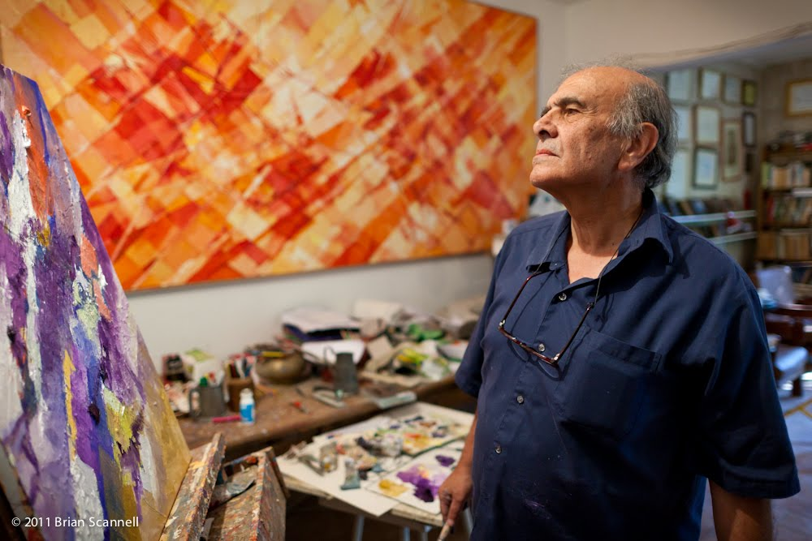

For image copyright: Brian Scannell; happymediumstudios.blogspot.com

For more images, contact Khalid Khreis at Jordan National Gallery: [k.khreis@nationalgallery.org](mailto:k.khreis@nationalgallery.org)